**Storyboard Plan**

My goal is to determine what are the common differences between countries with a high WRI and low WRI.

* **Who?** This type of knowledge has the power to prevent undue hardship among various populations. This is also aimed at aid organizations so they may be guided where their resources may be needed the most. Another target is worldwide governments who may want to implement preventive policies against natural disasters worldwide.
* **What?** Analyze WRI and its associated variables to find patterns that affect the WRI score of various regions.
* **When?** This data covers the time span of 2011-2021.
* **Where?** Worldwide
* **Why?** This project aims to better understand the complex relationship between countries’ governments and policies with natural events to get a concept of the overall risk index score of various regions. This relationship helps organizations to understand a region’s weakness and get closer to discovering methods to prevent disaster and its outcomes.

**Slides (message and supporting visuals)**

* **Introduction**

* + **Message**
    - Overview and definition of World Risk Index and its components: Exposure and Vulnerability (includes Susceptibility, Coping and Adaption)
    - Includes the objective of the project
  + **Visuals**
    - Image of World Risk Index formula
    - Pie Charts showing percentages of WRI, Exposure and Vulnerability levels.
* **Latitudes**

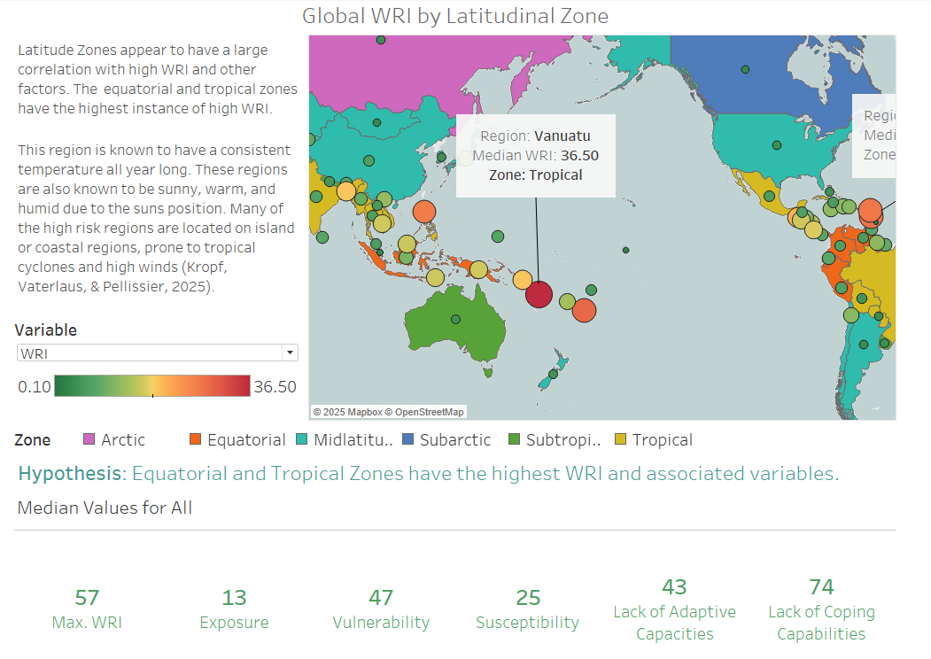

* + **Message**
    - Latitude zones have a high correlation with WRI.
    - Information about tropical and equatorial zones
    - **Hypothesis**: Equatorial and Tropical Zones have the highest WRI and associated variables.
  + **Visuals**
    - Map with countries colored by zone
    - Include top layer of Exposure, Vulnerability, Susceptibility, Coping and Adaptation levels.
    - Include Median values of variables when choosing any country.
* **Linear Relationships**

* + **Message**
    - Tropical and Equatorial zones have higher scores than other zones. Include text breakdown and explanation for each variable
  + **Visuals**
    - Scatterplot shows the relationship between WRI, Exposure and Vulnerability levels and latitude. These will also be colored by zone.
* **Cluster Analysis**

* + **Message**
    - Among the high WRI zones (equatorial and tropical) there are two zones.
    - Overview of some basic statistics of each zone
  + **Visuals**
    - Scatterplot of WRI vs Latitude colored by zone and clusters showing by the shape of the point.
* **Cluster Comparison**

* + **Message**
    - Differences between high WRI and low WRI tropical and equatorial regions are exposure.
    - Preventative treatments may be the best way to handle these.
  + **Visuals**
    - Boxplots showing differences between the two clusters for each variable.
    - Butterfly charts to show counts in different categories of variable scores between cluster 1 and cluster 2
* **Climate Change**

* + **Message**
    - Climate change and how it can affect vulnerability and exposure scores.
  + **Visuals**
    - Temperature anomalies over time.
* **Conclusion**

* + **Message**
    - Case studies show that exposure is the largest differentiator between cluster 1 and cluster 2
    - I specifically point out that the difference between Samoa and Vanuatu is exposure despite being located in the same zone.
    - Call to action is climate change
    - Latitudinal zone is a confounding variable, but the true high WRI is mainly predicted by weather patterns/exposure. Therefore, climate change advocacy is integral to maintaining healthy WRI scores worldwide along with creating strong coping and adaptation strategies to lower vulnerability in countries with already high exposure scores.
  + **Visuals**
    - Variable line plots of case study countries for comparison purposes.

Uses of Study

* Provides a data-driven report on methods to reduce disaster in countries worldwide by highlighting the importance of climate change advocacy to prevent high exposure and reducing vulnerability scores in countries with high exposure

Next Steps

* Study on scores overtime – see if they correlate with climate change
* Study on scores overtime – do countries that implement policies to reduce disaster risk receive a decrease in their scores

Limitations

This dataset is only current through 2021 so any risk index scores may be inaccurate to the country’s current state. This dataset should only be an indicator for possible future analyses of specific countries and methods to improve their risk score. Users should be sure to research each specific country rather than assuming they know the specific realms of aid needed with the scores given in this study. The scores supplied in this dataset provide a good overview but not answers for informed solutions on a country level.